Introduction
Whenever I start a trip, I always ask who is carrying specific group equipment. I do this BEFORE we run the shuttle. For most white-water trips, my order of priorities is:
- First Aid Kit (FAK) – By far the most important group gear item.
- Two full size throw ropes
- A breakdown paddle or hand paddles in case someone loses theirs
- Pin Kit
- Sometimes a Repair Kit
Pin Kits serve several purposes but are mostly used to assist in retrieving a boat that is pinned. Some other uses are:
- Removing strainers
- Getting a car out of a ditch
- Anyplace mechanical advantage is needed
- Several First Aid Applications
- Repairing a broken backband
- Assisting in difficult/steep portages
- Evacuation

Unpinning Boats
Before resorting to mechanical advantage systems to free a boat, always try to find the weak point and use manual boat movement. This is far safer than running lines across busy streams and does far less damage to boats. Examine the current forces and try to use them to your advantage. Spinning the boat along its axis will quickly drain water inside the boat causing it to float and come free. Also examine any pin bars you are attaching a carabiner/rope to ensure they are not loose to begin with. A separate tag line is a wise practice as well, secure to a tree anchor with a tensionless hitch – when the boat is freed it will quickly head downstream (might even get pinned again).

Pin Kit Components
A commonly accepted practice for building a Pin Kit is high quality components (climbing grade) and the acronym: 4, 3, 2, 1.
- Four Locking Carabiners (never use non-locking carabiners as its far too easy for a line to open the gate)
- Three Pulleys (ideally Prusik Minding Pulleys – PMP). These have a squared off bottom rather than a rounded bottom.
- Two pre-tied Prusik Loops
- One 20’ – 30’ length of 1” Tubular Webbing (typically 4,000-pound breaking strength)
Notice I didn’t mention rope. Everyone should be carrying a throw rope on them. For Mechanical Advantage systems, you should have two full size throw ropes:
- 65’ to 70’ long
- 5/16” or 3/8” in diameter
Avoid 1/4” rope, especially polypropylene as it’s far too hard to pull on and generally not strong enough.

Carabiners
Like mentioned previously, carry only locking carabiners that are climbing grade and contain only one metal alloy to avoid electrolysis. Here are two of my favorites:
- Omega Pacific Standard D Screw Locks:
https://thefirestore.com/Omega-Standard-D-Aluminum-Carabiner?sku=OPSTANSG-BLU&utm_source=googlebase&utm_medium=cpc&utm_campaign=googlebase&utm_content=182931&gad_source=1&gad_campaignid=21311466686&gclid=Cj0KCQjwnJfEBhCzARIsAIMtfKLBjQKByNs2_6ODdEkM9SMidllsSJaY_6yB_6cmYIrnz5pEZFc6xkQaAtosEALw_wcB
- Petzyl AMD Trilact Carabiners:
https://www.gmesupply.com/petzl-william-triact-lock-aluminum-carabiner-gray?utm_term=&utm_campaign=**LP+-+Shop+-+pMax+-+Tower+Climbing+-+General&utm_source=adwords&utm_medium=ppc&hsa_acc=4386758471&hsa_cam=20918384770&hsa_grp=&hsa_ad=&hsa_src=x&hsa_tgt=&hsa_kw=&hsa_mt=&hsa_net=adwords&hsa_ver=3&gad_source=1&gad_campaignid=20908248705&gclid=Cj0KCQjwnJfEBhCzARIsAIMtfKKq8_vsCwXQ3KVO7BV8Yd3f-31uxSo9R9FotzcghjuuS0yI0tjl-zAaAtbzEALw_wcB
I have had both for several decades with zero maintenance or any issues. Auto-locking carabiners in general are more expensive and don’t last as long as simple screw lock carabiners. Avoid magnetic locking carabiners as they will rust very quickly.
Never use grease or oil on carabiners – both are grit magnets. Pure graphite spray works well and WD-40 Specialist Dry Lube is even better:
https://www.walmart.com/ip/WD-40-Specialist-Dry-Lube-with-PTFE-Lubricant-with-Smart-Straw-Spray-10-oz/39954760?wmlspartner=wlpa&selectedSellerId=0&selectedOfferId=52364F73181F4CE996297C198F8FDD38&conditionGroupCode=1&wl13=2015&gclsrc=aw.ds&adid=2222222227739954760_117755028669_12420145346&wl0=&wl1=g&wl2=c&wl3=501107745824&wl4=pla-394283752452&wl5=9008156&wl6=&wl7=&wl8=&wl9=pla&wl10=8175035&wl11=local&wl12=39954760&veh=sem_LIA&gclsrc=aw.ds&gad_source=1&gad_campaignid=12420145346&gclid=Cj0KCQjwnJfEBhCzARIsAIMtfKLhEz6Ui6JxYIEh2XmsoNo9W2MM5uIFDW2UK16Kkn0R3XNAkYiEiu8aAjJIEALw_wcB
Inspect carabiners once a year to ensure they open and close easily.

Pulleys
Pulleys are what enable mechanical advantage. The general rule of thumb (ROT) is the pulley needs to be 4 times the diameter of the rope to reduce friction and maintain full strength of the rope. A half inch rope would require a pulley with a minimum diameter of 2” – recommended for Raft Pin Kits. Fortunately, kayaks entrap far less water than rafts so a 1” micro-pulley is perfect and saves a lot of money.
Always go for Prusik Minding Pulleys (PMP) (squared off bottoms). A rounded bottom pulley requires a Bachmann Hitch for the Prusik Loop (BMP). This is what they look like:
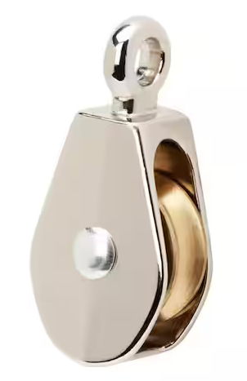
Here are examples of SMC PMP Pulleys:

- 1” SMC Micro-Pulley:
https://www.nrs.com/smc-crx-1-pulley/pln3?utm_campaign=shop_comp&utm_source=google&utm_medium=buy_now&utm_term=goog_product_45251.02&utm_campaign=&utm_source=google&utm_medium=cpc&gad_source=1&gad_campaignid=22469423247&gclid=Cj0KCQjwnJfEBhCzARIsAIMtfKItCuecTADgwW-TbvfDh1d901IHDqEOLUsACof_mW_8McPqZxa86gcaAs_kEALw_wcB
- 2” SMC Pulley:
https://www.nrs.com/smc-2-swiftwater-pulley/p76n

Prusik Loops
A Prusik Hitch is a hitch that secures an attachment to your rope using friction. Under load, it stays put. When the load is released, it’s easy to move the hitch up or down the rope. For a pin kit, you need high grade climber accessory cord that is between 50% - 75% of the diameter of the rope you are attaching to. I like a length between 4.5’ to 5’ in length. Good diameters are 5 mm to 7 mm. Avoid New England rope which is commonly sold in packages at REI, get the cut to length ones by visiting the REI store. These are of much higher quality, generally PMI or BlueWater.
Now that you have the accessory cord, you will need to tie two Prusik Loops. This is done using either a double or triple Fisherman Knot.

One Inch Tubular Webbing
Although anchors can be made with rope, webbing is a far better choice as its inexpensive, doesn’t lose strength in tight bends and provides a wide surface for friction. I personally use 20’ for constructing a Guide Belt or the full 30’ for a Pin Kit that is stored in a boat.
Here is a great example from BlueWater:
https://www.rei.com/product/118266/bluewater-1-climb-spec-tubular-webbing-30-ft?sku=1182660004&store=152&gStoreCode=152&gQT=1

Assembled Pin Kit
Any bag will do to store a full pin kit in a boat, but a decent dry bag is your best option. Another option is wearing your Pin Kit. This has huge benefits:
- Easy to swim with (don’t have to carry a bag)
- Always on you so you have it when you need it – no searching inside someone’s boat
The trade-off is a potential snag hazard which is mitigated by securing under your spray skirt tunnel.
First, construct a Guide Belt:
- Create loops on each end by folding once and tying an overhand knot.
- Now, daisy-chain the webbing to shorten and attach with a auto-locking carabiner.
The PFD Boat Kit Presentation describes fully and provides other tips & tricks.
https://www.teamriverrunner.org/wp-content/uploads/2021/10/PFD-Boat-Kit.pdf
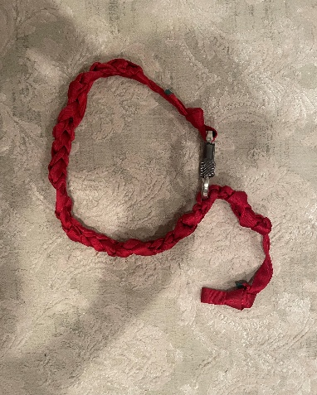
Now stuff three carabiners, three micro-pulleys and two prusik loops in your rescue vest chest pocket – these don’t take up much space.

Conclusion
Pin Kits can be useful for a wide variety of purposes. When thinking about using to unpin a boat, always use a tag line and try manipulating the boat by hand first. I find Mechanical Advantage systems to be far more applicable to moving heavy objects like strainers. Get proper training in Swiftwater Rescue so you understand proper safety protocols. Commercial Pin Kits are expensive and always lower in quality than those you construct yourself.

