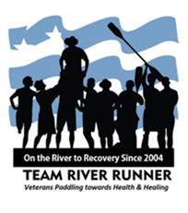

Helmet & PFD Policy

Background
The number one cause of fatalities on paddling trips is not wearing a Personal Floatation Device (PFD). The US Coast Guard and many states often have laws in place mandating the use of life jackets (US Coast Guard Guidance). The US Army Corp of Engineers has had a strict lifejacket policy in place for many decades.
Wearing a helmet may be inconvenient in some venues but is always encouraged. A very common issue for veterans is Traumatic Brain Injury (TBI). Wearing a properly fitted helmet can reduce occurrence and severity of these types of injuries.

TRR National Policy Statement
- PFD must be worn while on the water and within 10’ of the shoreline.
- Helmets & PFD must always be worn when paddling whitewater Class II and above in difficulty regardless of craft.
- Wearing a helmet is advised but not mandatory on flat water venues with a consistent depth of 3’ (1 Meter) or more.
- On Class I venues with deep water, TRR allows the event leader to make a judgment call and that individual’s decision is final.
- No one shall ever be persuaded not to wear a helmet if they choose to do so.
- TRR Event leaders will examine the venue for potential head injury potential and mitigate and/or require wearing a helmet.
- PFDs are required to be worn while in the pool paddling

Compliance
The TRR Event Leader is responsible for enforcing this policy. Any individuals choosing not to follow the above policy will be asked not to participate. Any injuries on a TRR sanctioned event must be reported to TRR National via the TRR Incident Report Form. TRR National reviews reported injuries to improve training and documentation resources.

